AWG Developments

Ryan Barnes, Tim Keller, and Song-i Han

We note several developments that we made to our home-built pulse EPR spectrometer that are motivated out of necessity. Mainly these developments aim at improving the receiver sensitivity as well as the fidelity of the pulse synthesizing unit. The issues hindering our spectrometer are as follows (1) a low frequency baseline signal, (2) a high noise figure of the detection electronics, and (3) a low power microwave leakage from the pulse synthesizer.

# Low frequency baseline issue:

The receiver suffered from a low frequency baseline issue. We found this was caused by the low frequency bound on the bandwidth of the video amplifiers inserted after the IQ mixer in the heterodyne detection system. This previously prevented the detection of EPR signal without off resonance background subtraction as the low frequency baseline did not cycle with the phase of the microwave excitation pulse preventing the full applicability of a phase cycling scheme. A representative dataset of signal taken on solid BDPA is shown to illustrate how the microwave baseline does not cancel out after a +x -x phase cycling scheme, Fig 1. 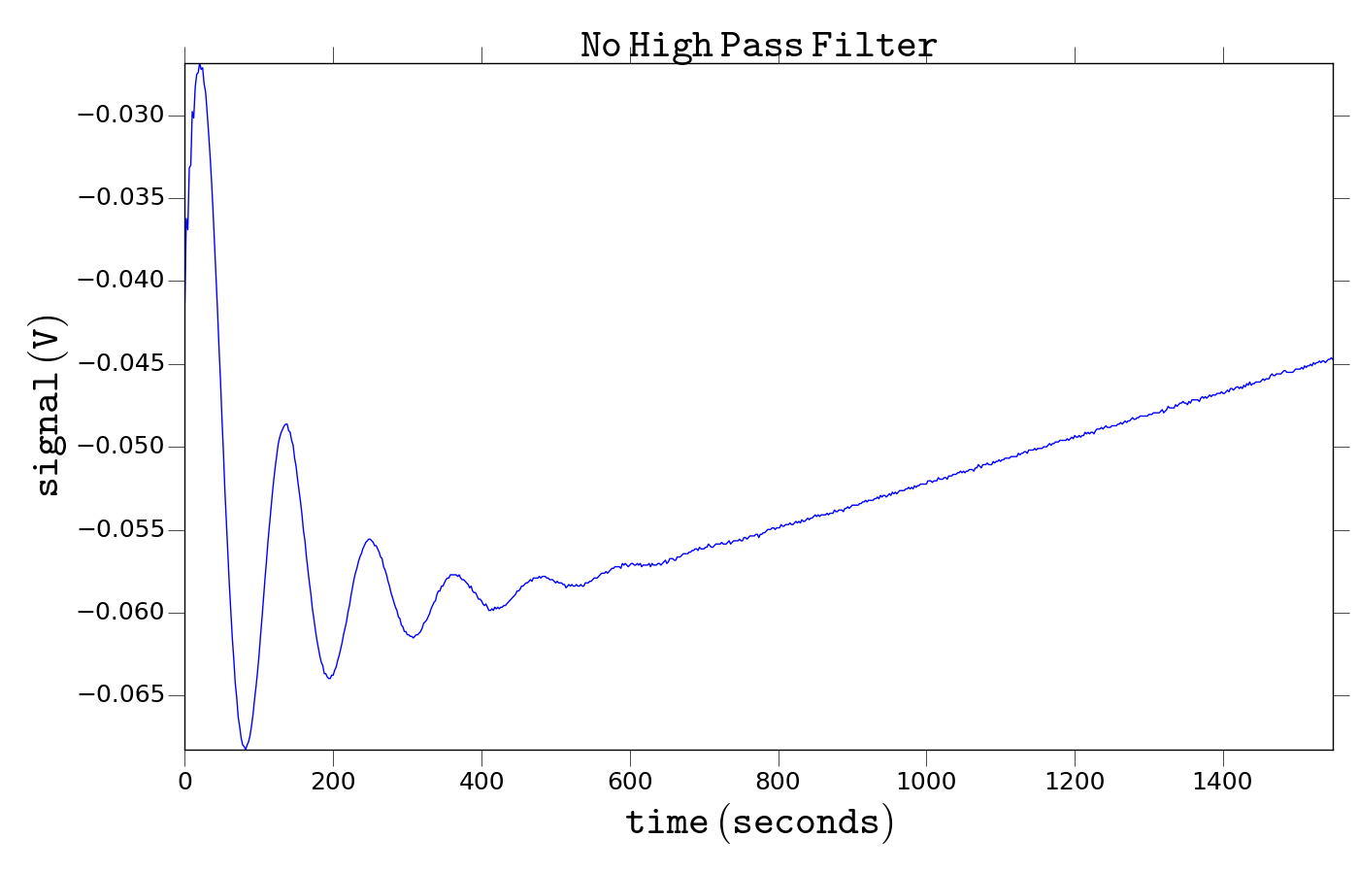

Figure : Phase cycled free induction decay signal from solid BDPA. The non zero baseline component is not removed by the +x -x phase cycle of the excitation pulse. This indicates that the baseline is not microwave ring-down but in fact due to the detection electronics.

To solve this issue we inserted higher bandwidth (0.1 - 1000 MHz) video amplifiers (Mini Circuits ZFL-1000LN+) and 25 MHz high pass filters (Mini Circuits SHP-25+) to filter off any low frequency oscillation. We also used the DAC boards to modulate the excitation pulse by 150 MHz relative to the carrier microwave frequency to prevent the attenuation of EPR signal by the high pass filters, a phase cycled FID shown in Fig 2. This produced a high fidelity signal, Fig 3, we show the comparison of EPR signal with and with-out the band pass filters in place. We see both a large DC offset, indicated by the spike at zero frequency, as well as a negative spike at the minus frequency both issues are not seen in the signal taken with the 25 MHz high pass filters in place. For reference we show the overlay of the 150 MHz modulated signal taken with the high pass filters at zero frequency.

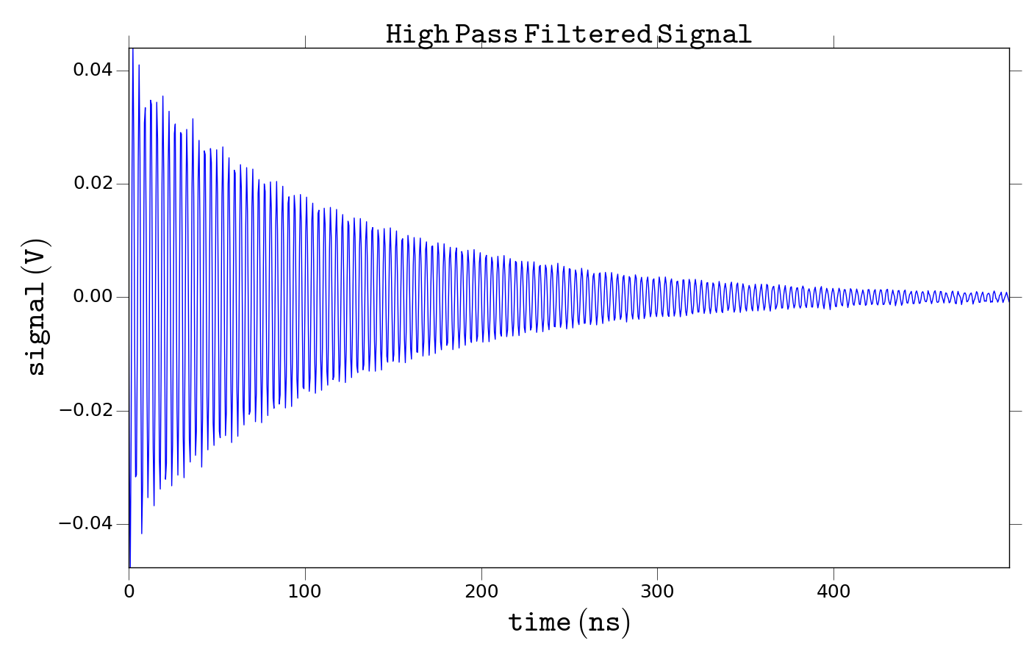

Figure : Phase cycled FID from BDPA taken with the 25 MHz high pass filters in place. Note that the excitation pulse is modulated by 150 MHz relative to the carrier frequency such that the high pass filters do not attenuate the EPR signal. The high pass filters do indeed remove the low frequency baseline.

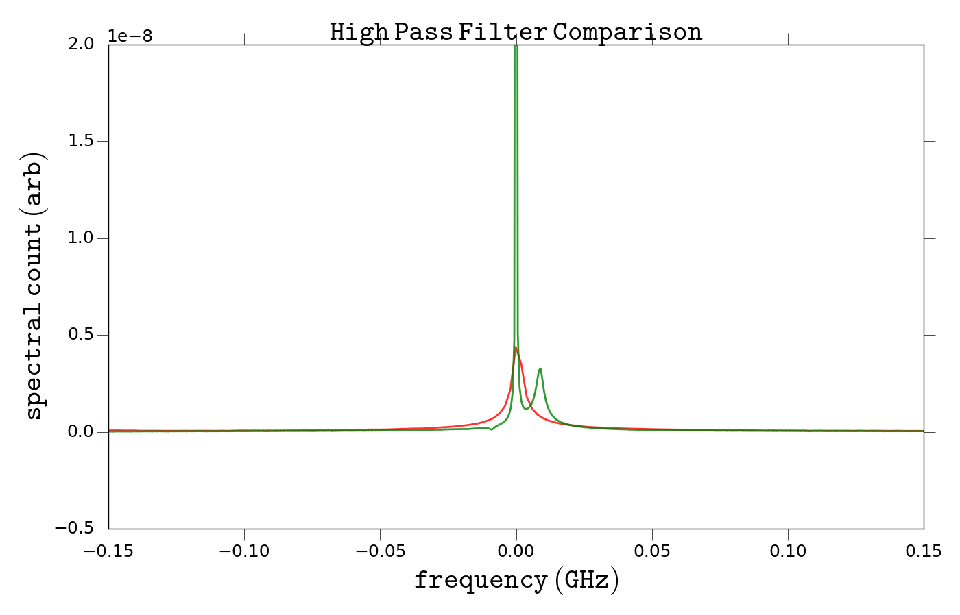

Figure : Comparison of EPR spectrum take with (red) and without (green) the high pass filters in place. The signal taken with the high pass filters in place is left shifted by 150 MHz to overlay with the signal taken without the high pass filters. The large spike at 0 Hz in the signal taken without high pass filters is due to the non-zero baseline.

# High Noise Figure of Detection Electronics

Before modification we found the noise figure of the microwave detector was ~5.5 dB relative to thermal noise at zero frequency. In the ideal case the noise figure should be about 3 dB. We inserted a low noise figure LNA (Miteq AMF-3F-09001000-08-8P), with a noise figure of 0.8 dB and a gain of 34 dB, to try and combat this issue. The noise figure of the microwave receiver was negligibly improved to 5.5 dB by the addition of a new low noise amplifier, Fig 4.

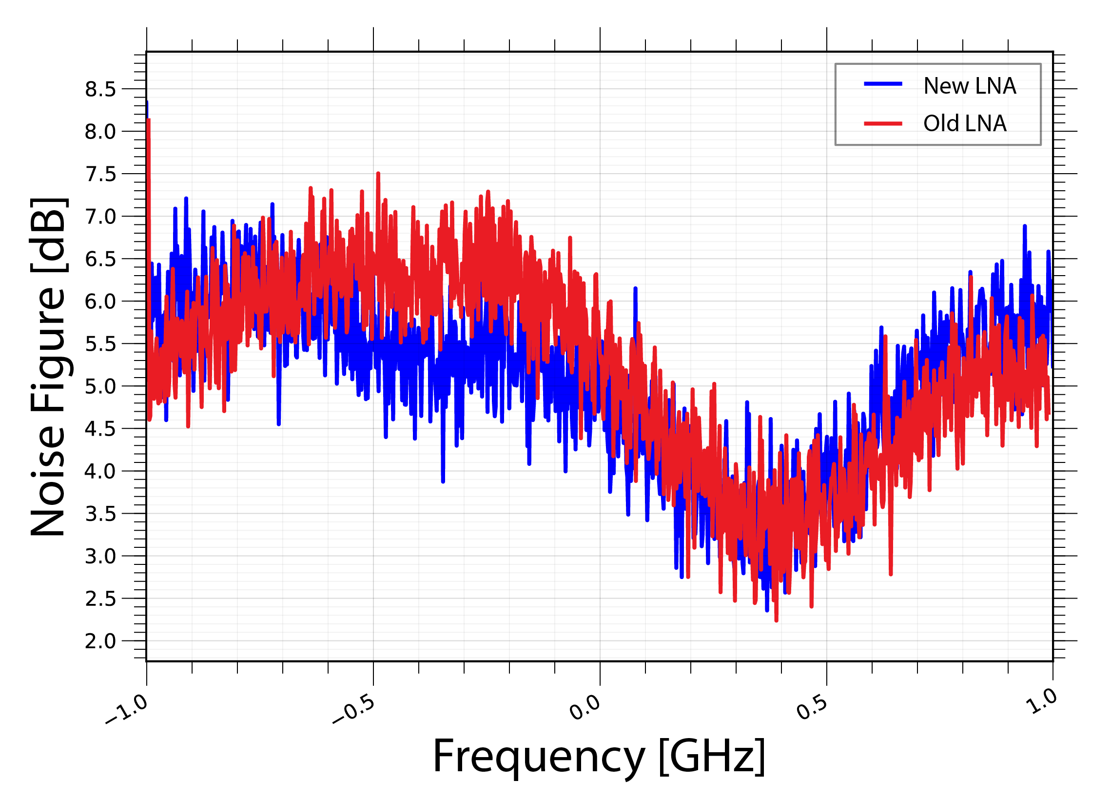

Figure : Comparison of the receiver noise in frequency domain with the two LNAs blue (0.8 dB noise figure) and red (1.3 dB noise figure).

# Low Power Microwave Leakage

The pulse synthesizer had a low power microwave leakage which proved problematic after amplification with a TWT amplifier. We found this low power leakage was sufficient to drive the spin system to saturation during a T­­2 relaxation experiment. We solved this issue by placement of a high isolation microwave switch after the IQ synthesizer. The switch improves the fidelity of the microwave pulses to an 80 dB on off isolation. A sample waveform is shown in Fig 5.

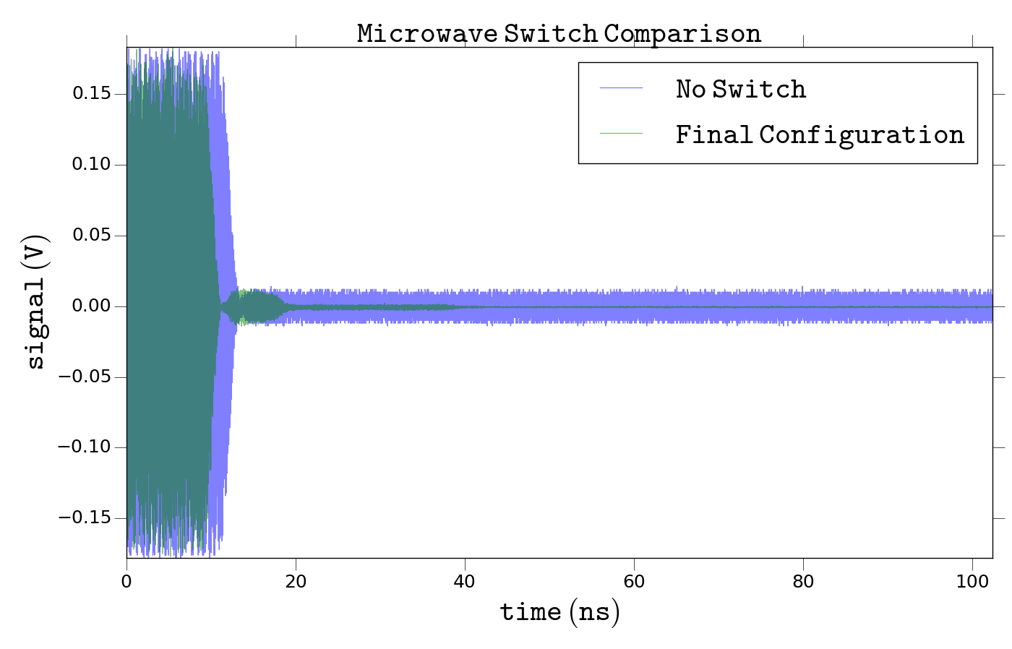

Figure : Comparison of the microwave pulse taken with (green) and without (blue) the high isolation microwave switch.